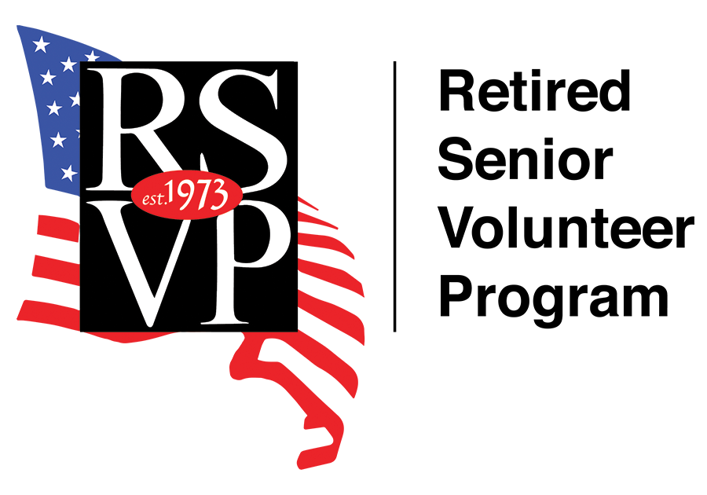

RSVP of Central Oklahoma, Inc.
Volunteer Application Form

Name: Birthdate: _______________________

Mailing Address:

Email: Home Phone: _______________________

Cell Phone: Gender: _______________________

Do you have any physical/medical limitations? _______________________

Are you a past member of RSVP?: Yes No

Are you a Veteran?: Yes No

Do you drive?: Yes No

Ethnicity: _______________________ (You are not obligated to disclose your ethnicity. We request this information to only comply with federal civil rights laws.)

Have you ever been convicted of a criminal offense?: Yes No
(If yes, please attach an explanation of charges, date of offense and status of the charges on a separate sheet to be included with this application.)

Employment Experience:
_______________________________________________________________________________
_______________________________________________________________________________
_______________________________________________________________________________
_______________________________________________________________________________
_______________________________________________________________________________
_______________________________________________________________________________

Special Skills/Interests:
_______________________________________________________________________________
_______________________________________________________________________________
_______________________________________________________________________________
_______________________________________________________________________________
_______________________________________________________________________________
_______________________________________________________________________________

How did you learn about RSVP?:
_______________________________________________________________________________
_______________________________________________________________________________
_______________________________________________________________________________
_______________________________________________________________________________
_______________________________________________________________________________

Have you ever volunteered before?: Yes No

Days/Hours Available:
_______________________________________________________________________________
_______________________________________________________________________________
_______________________________________________________________________________

As a volunteer, you will receive free accident and personal liability insurance. Please provide the following information.

Emergency Contact ______________________________________________________________

Relationship: Phone: ___________________

Beneficiary for RSVP Supplemental Accident Insurance __________________________________

Relationship: Phone: ___________________

Please indicate if RSVP may have permission to use your likeness?

I hereby grant RSVP of Central Oklahoma to use my likeness in photographs/videos in any and all of its publications or on the World Wide Web, whether now known or hereafter existing, controlled by RSVP of Central Oklahoma in perpetuity. I will make no monetary or other claim against RSVP of Central Oklahoma for the use of these photographs/videos. Yes No

I do not give permission to use my likeness in photographs/videos to RSVP of Central Oklahoma.
Yes No

Please indicate if RSVP may have your permission to perform a confidential background check?

I understand that RSVP may at their own expense and discretion choose to perform confidential background checks on any/all registered members. I hereby give my permission for such checks to occur. Yes No

I do not give permission to perform confidential background checks. Yes No

Certifications
By signing below, I acknowledge that I have read and understand the following statements: 1) I hereby state that I am 55 years of age or older and offer my services as a volunteer for RSVP of Central Oklahoma. I understand that I am not an employee of RSVP of Central Oklahoma, the volunteer agency in which I serve, or the Federal Government and agree to serve without compensation. 2) I understand that in my capacity as a RSVP volunteer I may come into contact with confidential information. I agree to protect this information to the best of my ability and not to disclose it during or after my service as a volunteer has ended. 3) I understand that if I use my personal automobile in my volunteer service, I will arrange to keep in effect automobile liability insurance equal or greater to the minimum requirements of the state of Oklahoma. I will also keep in effect a valid driver’s license.

Volunteer Signature______________________________________ Date ____________________

